**Practical No: 7**

**Program 1:**

> exam_data=data.frame(

+ name=c('Kaysan','Aryan','Arjun','Nicklodean','Nikhil'),

+ score=c(65,75,85,55,47),

+ attempts=c(1,1,1,2,1),

+ qualify=c('yes','yes','yes','no','no')

+ )

> print("Original dataframe:")

[1] "Original dataframe:"

> print(exam_data)

> result=exam_data[c(3,5),c(1,3)]

> print(result)

> print("This Practical Was Performed By Kaysan Shaikh-4334")

**Output 1:**

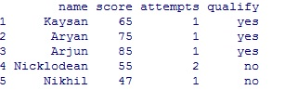

**Output 2:**

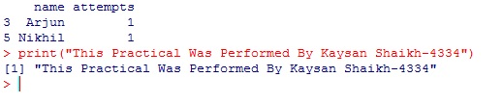

**Program 2:**

**> employee_data=data.frame(**

**+ name=c('Kaysan','Akash','Aryan','Arjun','Nikhil','Nilesh'),**

**+ salary=c(77000,55000,67000,42000,52000,59000),**

**+ department=c('IT','CS','Mechanics','Civil','Aeronatical','Electronics'),**

**+ experience=c(2,3,2,1,1,2))**

**> print(employee_data)**

**> result=employee_data[c(3,5),c(1,3)]**

**> print(result)**

**> print("This Practical Was Performed By Kaysan Shaikh - 4334")**

**Output 1:**

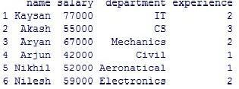

**Output 2:**

